
“Hey Diddle diddle the median’s the middle,
You add and divide for the mean.
The mode is the one that appears the most,
And the range is the difference between.”

Heights of Australian Prime Ministers (cm)
166, 193, 184, 183, 182, 181, 176, 178, 173, 170, 175, 175, 168, 183, 183, 179, 174, 170, 175, 178, 194,178, 183, 178

- Enter all the heights into excel as a column (step1). Now select the column by pressing on the A at the top of the column and find the “sort and filter” button on the tool bar. Choose “sort smallest to largest” (step 2). Finally, type the 7 formulas into column C and write labels for them in column b as pictured below (step 3).

2
1
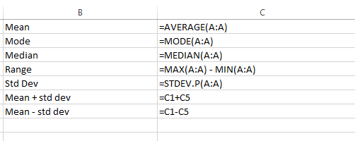
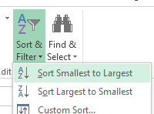
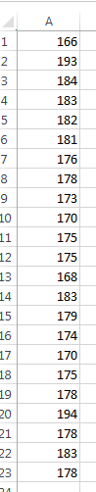
3
- What does the standard deviation tell us about the data?

- What does the “mean + standard deviation” and “mean - standard deviation” tell us about the data?

- Try these formulas to find the quartiles.
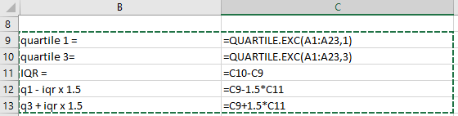

- What does the q1 – iqrx1.5 and the q3 + iqr x 1.5 formulas calculate for us?

- Write down the data the formulas have given you in the table on the next page in the “Original” Column.

- Now delete the three lowest scores by selecting the cells containing those three heights and hitting the delete key.
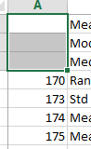

- Check the results provided by the formulas has changed and write the new results in the table below in the “New” column.

- Can you explain why each piece of data has changed?

 | Original | New | How did it change and Why?
MEAN
MODE
MEDIAN
RANGE
Standard Deviation
Mean + Standard Deviation
Mean – Standard Deviation

9. In excel press “Ctrl+z” or use the back button to return the deleted data.
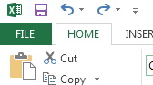

- What effect does removing the tallest Prime Minister have on the data?

 | Original | New | How did it change and Why?
MEAN
MODE
MEDIAN
RANGE
Standard Deviation
Mean + Standard Deviation
Mean – Standard Deviation

- Create a table with the formulas as per below and highlight the table.
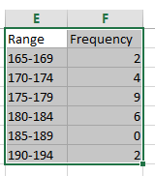

- Now Click the insert tab and choose a column graph. Choose a 2-d clustered column (though if you have time – have a look at more graphs to see how they look).
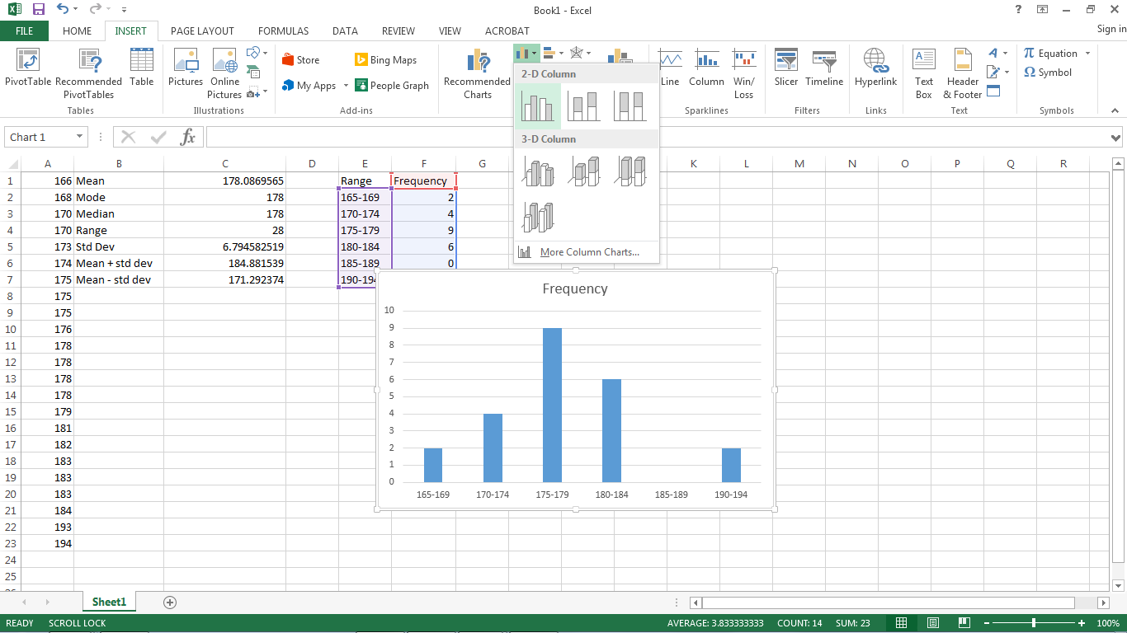

End of Workshop

